Chapter 7, Problem 47.

Determine v(t) for t > 0 in the circuit in Fig. 7.114 if v(0) = 0.

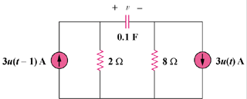

Figure 7.114
For Prob. 7.47.

